# Manjimup S.H.S Year 12 2016

# Mathematical Methods Investigation 1

Validation

**PROBABILITY**

Name:

DATE: Friday May 6th 2016

TIME ALLOCATED: 60 Minutes

Question 1 [1,3,2,2 = 8m]

The age of 4 children in a family are 7, 8, 10 and 13.

1. State the mean age 
2. Use the formula shown to calculate the variance of ages. 

Show all working below.



1. Show working to verify that the alternative formula gives the same answer for variance.

Show all working to justify your answer.

1. Find the mean of a set of 5 scores with a standard deviation of 1.4 and 

Question 2 [2,2 = 4 marks]

A jelly bean company produces packets of jelly beans which state “average contents 200”.

They have two machines Machine A and Machine B which package up the jelly beans.

|  |  |
| --- | --- |
| Machine A 100 samples | |
| *Jelly Beans* | *Packets* |
| 198 | 15 |
| 199 | 18 |
| 200 | 29 |
| 201 | 13 |
| 202 | 12 |
| 203 | 11 |
| 204 | 2 |

100 packets coming from Machine A are counted and the

results shown in the table to the right.

1. Use your calculator to find the mean and standard

Deviation of jelly beans from each packet for

Machine A.

Mean: Standard Deviation:

Machine B is also measured and has mean of 200.54 beans with a standard deviation of 1.1.

1. Which machine seems to give more reliable quantity? Justify your answer.

Question 3 [3,2 = 2 marks]

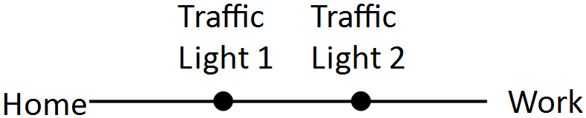

Kelly drives to work each day and has to go through two sets of

traffic lights. She knows from experience that she has a 30%

chance of a red light at each set of traffic lights.

1. Let X be the number of red lights Kelly encounters each day.

Calculate and complete a probability distribution for X.

|  |  |  |  |
| --- | --- | --- | --- |
| X | 0 | 1 | 2 |
| P(X = x) |  |  |  |

1. On any single day, Kelly will be late for work if she doesn’t get all green lights.

Find the probability that Kellie will be late for work two days in a row.

Question 4 [1,2,2,1 = 6 marks]

You are going to run a simulation trial of 50 days on your Casio for the Kelly’s traffic light situation to find on each day how many red lights she experienced.

1. Write the calculator command that will simulate this. ……………………………………….

b) Carryout 50 trials on your calculator and record the frequency and relative frequency below by using a histogram on the Statistics Aplet of your calculator.

50 trials X = number of red lights

|  |  |  |  |
| --- | --- | --- | --- |
| x | 0 | 1 | 2 |
| Frequency |  |  |  |
| Relative frequency |  |  |  |

1. Compare the trials from above to the theoretical chances in Question 3.

Discuss any similarities and differences.

1. Predict the effect on your answer to the previous question if you increased the number of trials from 50 to a larger number.

Question 5 [2,4 = 6 marks]

A work colleague of Kelly is Scott. He must pass through seven traffic lights to get to work.

Scott travels on a priority road and has a 80% chance of a green light at any of these traffic lights.

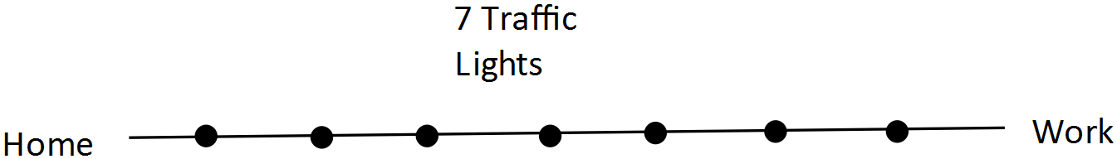

1. By using a shortcut method find Scott’s chance of getting exactly 6 green lights.

Show your method.

1. Scott will get to work on time only if he gets more than 4 green lights. Find the probability Scott gets to work on time, to the nearest whole percent.

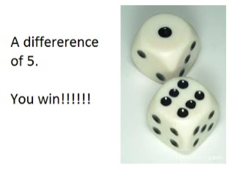Question 6 [2,2,3,2 = 9 marks]

A club is running a gambling night to make money. One game is called 4’s and 5’s.

The game costs $1 to play. Two six sided dice are rolled and the smaller number on the dice is subtracted from the larger number, so no negative numbers are possible. If a difference of 5 comes up the gambler gets a payout of $10, if a difference of 4 comes up the payout is $3. All other differences pay nothing.

1. List the sample space for differences below.
2. If the random variable, X, is the players winnings complete the probability distribution.

|  |  |  |  |
| --- | --- | --- | --- |
| X | **+$9** |  | **-$1** |
| P(X = x) |  |  |  |

1. Calculate the expected profit of the club per game, to the nearest tenth of a cent.
2. To the nearest cent, find what the payout on the prize for getting a difference of 4 must be changed to so the club makes exactly 3 cents per game.

Question 7 [1,5,3,2 = 11 marks]

X

X

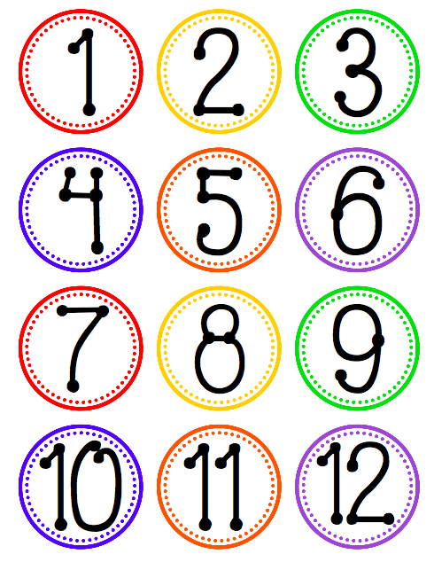

Live It Up Lotto has 12 numbers in a barrel.

The gambler pays $5 to play and selects 4 numbers.

4 Lucky numbers are drawn from the barrel.

X

MATCH 4: If you match all 4 numbers you get a $1000 payout.

MATCH 3: If 3 of your 4 numbers are Lucky Numbers

you get a $40 payout.

X

Anything else has no payout!

1. In how many ways can 4 numbers be drawn from 12?

**LIVE IT UP LOTTO**

***You pay $5 to play.***

***Numbers 1 to 12 are placed in a barrel.***

***You choose 4 numbers beforehand.***

***Four of the 12 numbers are drawn out of the barrel. These are called the Lucky numbers.***

***MATCH 4: If all of your 4 numbers match with the 4 Lucky Numbers drawn out your payout is $1000.***

***MATCH 3: If three of your lucky numbers match with the Lucky Numbers you get a $40 payout.***

1. Calculate the probability (as a fraction) of
2. MATCH 4
3. MATCH 3
4. getting no payout.
5. Find the expected result for the gambler per game. Show all working.
6. To the nearest hundred thousand dollars, how much would the gambling company expect to make in a year on Live it up Lotto, if the game was played once a week and an average of a quarter of a million entries were made each game?

Question 8 [2,2 = 4 marks]

The Saturday Lotto in Australia asks players to match 6 numbers from the 45 in the barrel.

This will win a player First Division Lotto.

1. What is the chance of a player in one game, matching their 6 numbers with the 6 drawn out?

Write your answer in the form 1 in …………………….

1. A player buys 12 games of Lotto every Saturday.

Find the number of years they would have to keep playing lotto before they would expect to win First division Lotto.

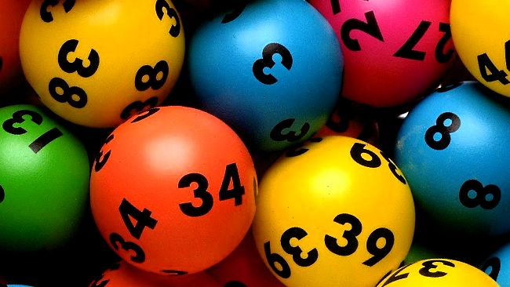

THE END

EXTRA WORKING PAGE